Double-sided Printed Tactile Display with Electrical Stimuli

【Main Content】:

In this paper, we have explicated a novel printed tactile display that can provide both the electrical stimulus and the electrostatic force. The circuit patterns for each stimulus were fabricated by employing the technique of double-sided conductive ink printing. Requirements for the fabrication process were analyzed and the durability of the tactile display was evaluated. Users’ perceptions of a single tactile stimulus and multiple tactile stimuli were also inves-tigated. The obtained experimental results indicate that the proposed tactile display is capable of exhibiting realistic tac-tile sensation and can be incorporated by various applications such as tactile sensation printing of pictorial illustrations and paintings. Furthermore, the proposed hybrid tactile display can contribute to accelerated prototyping and development of new tactile devices.

【Hybrid haptic display】：

We propose a novel technique to realize a hy-brid tactile display with multiple stimuli, leveraging electrical stimulus and electrostatic force. The proposed tactile display only requires small electrodes, which can be easily integrated in a thin substrate and miniaturized. Additionally, conductive inkjet printing combined with design by illustration software enables the fabrication of a variety of tactile devices that can be custom ﬁt to the user’s hand or body and applied to a wide range of practical and experimental uses. The electrodes can be fabricated using a ﬂexible substrate such as paper or PET ﬁlm, which is advantageous to not only whole-hand stimula-tion but also to tactile stimulation with high resolution. We fabricated a tactile display with conductive printing ink and evaluated perceived tactile sensation through the display.

【Contributions】:

1. We examined the characteristics of tactile sensation while applying electrical stimulus and electrostatic force.

2. We consider a prototyping technique with double-sided inkjet printing to fabricate hybrid tactile display which would be useful in subsequent haptics research.

3. We investigate how humans feel tactile sensations using our hybrid tactile display.

4. We show several potential applications using our hybrid tactile display.

【Equipment structure and principle】：（Detail in paper）

Electrostatic Force Tactile Display

Electrical Stimulus Tactile Display

【Experiments】：

**Evaluation 1: Range of Detectable Frequency Difference：**

We conducted experiments to clarify the range of detectable frequency differences of each stimulus by the user.

Results:

Experimental results are shown in Table 1 and 2. The par-ticipants were able to discriminate the stimulus under almost all experimental conditions of electrostatic force. However, the average rate of correct answers is 65 % (SD: 6.23): not high accuracy. The low recognition rate was the result of the narrow intervals of each selected frequency. We expect the discrimination rate to improve with wider intervals.

Although the recognition rate for the electrical stimulus was also low, but participants were able to sufﬁciently distinguish between the “low frequency” and “high frequency” electrical stimulus used in this evaluation.

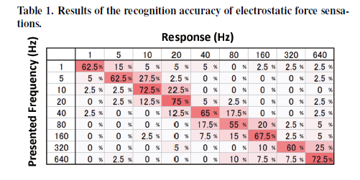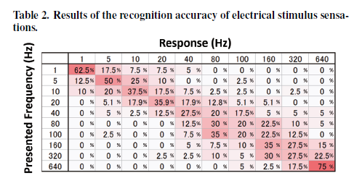

**Evaluation 2: Sensational Experiments：**

In this section, we describe the evaluation of how the partic-ipants experience the sensations presented by a hybrid tactile display using electrical stimulus and electrostatic force.

Results:

Sticky (S1) and Frictinoal (S2) Sensation

Bumpy (S3) and Touch (S4) Sensation

Temperature (S5), Hardness (S6), Pleasant (S7) Sensation

Perceived Sensation

Conclusion:

We conducted evaluations of the characteristics of tactile sensation while applying electrical stimulus and electrostatic force. Our evaluations showed that tactile sensation is inﬂu-enced by the interaction between electrical stimulus and elec-trostatic force with various frequency conditions.

【Applications】：

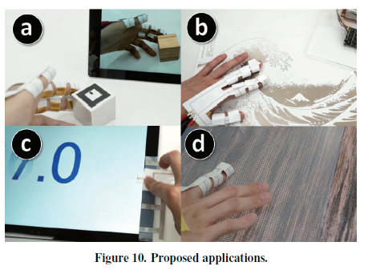

【Paper Conclusion】:

In this paper, we proposed a hybrid tactile display which can provide “electrical stimulus” and “electrostatic force.” We also proposed prototyping technique that fabricating the hy-brid tactile display using a double-sided inkjet printing. Our prototyping technique enable easy and inexpensive fabrica-tion of the experimental device and facilitates future work in the haptics ﬁeld.

We evaluated the user experience of the tactile sensations using combinations of electrical stimulus and electrostatic force. According to the results, tactile sensation is inﬂu-enced by the interaction between electrical stimulus and elec-trostatic force with various frequency conditions. The pro-posed hybrid tactile display using an electrical stimulus and an electrostatic force presents a more realistic tactile presen-tation that has richer information than tactile feedback with a simple stimulus.

